Site Header and footer content change

**Step1:** Login to admin section of your magento site

**Step2:** Click on Content 🡪 Configurations menu from the left navigation

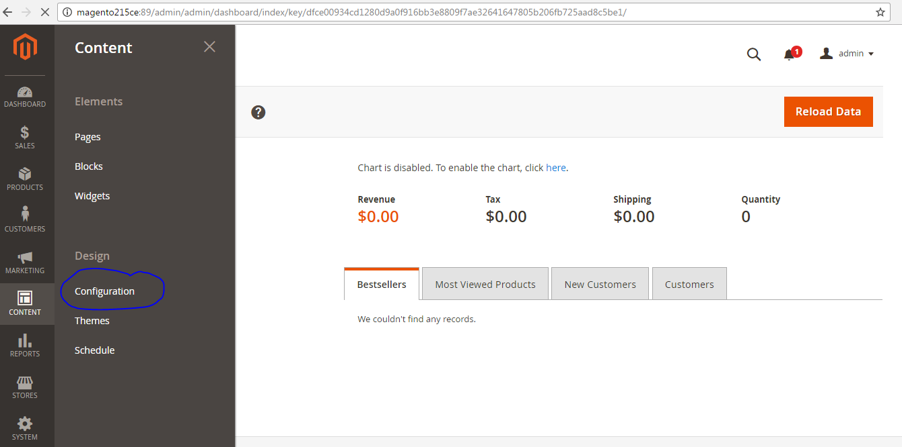

**Step3:** It will navigate to a list of stores available in your magento application

Click on edit of link of the website which you wanted to edit.

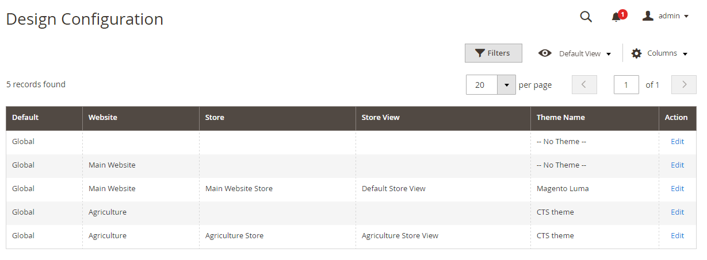

**Step4:** Go to Other settings and click on each tab diaplayed. You can edit HTML Head, Header, Footer, etc. Modify the content and click on Save Configuration button.

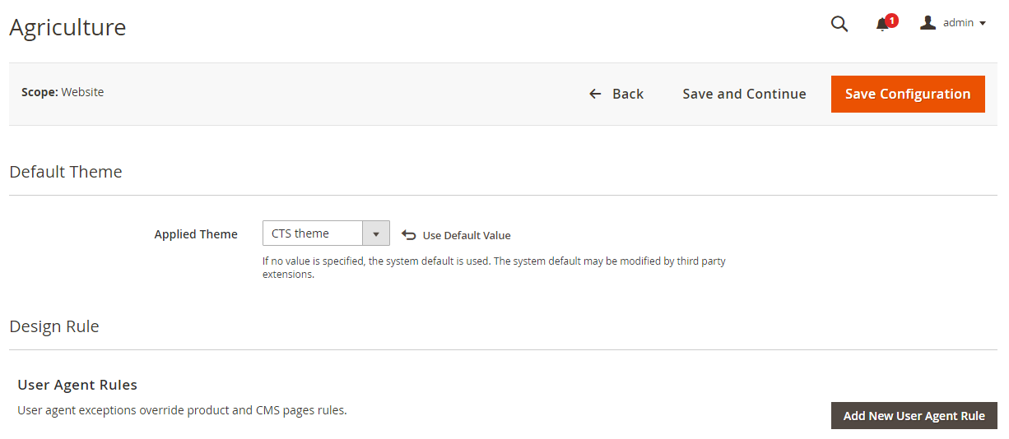

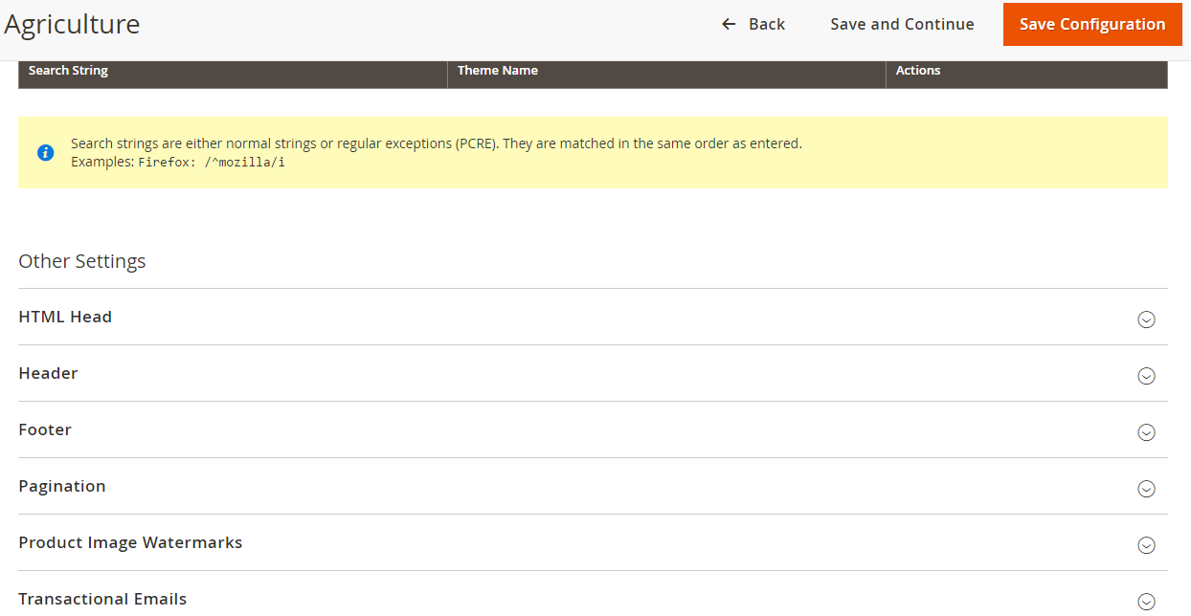

**Step5:** From the Click on Edit link of a store view and edit the Other settings for store view as we did for website. Follow the screenshots.

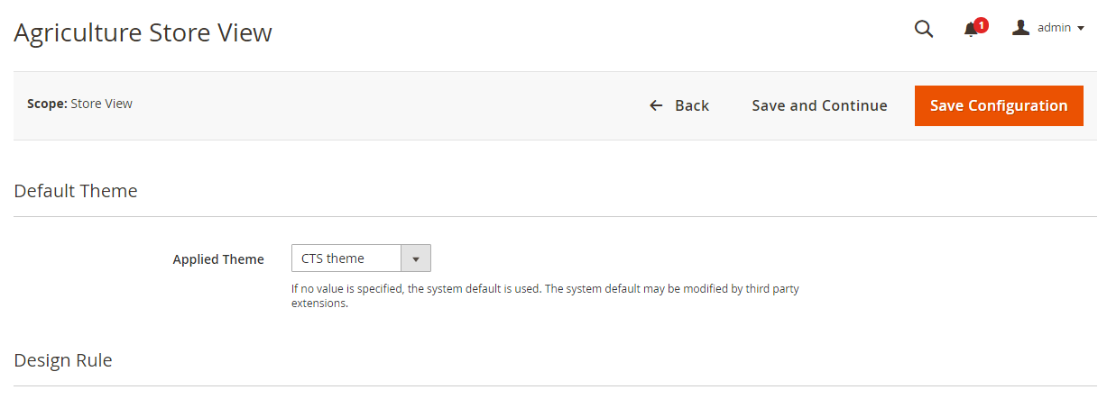

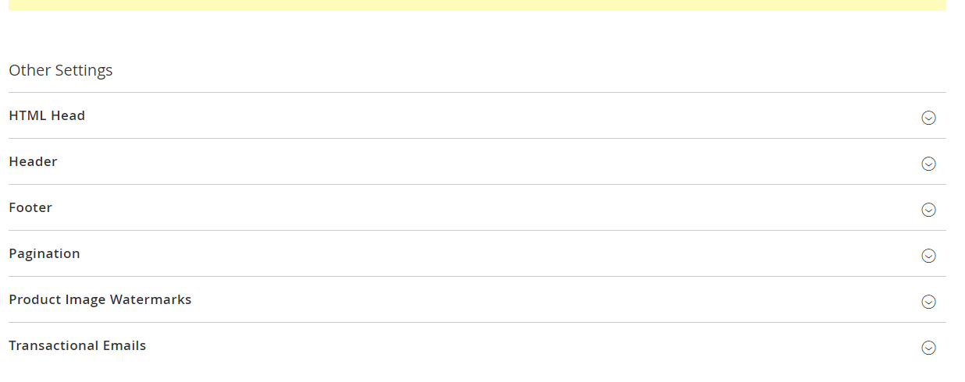

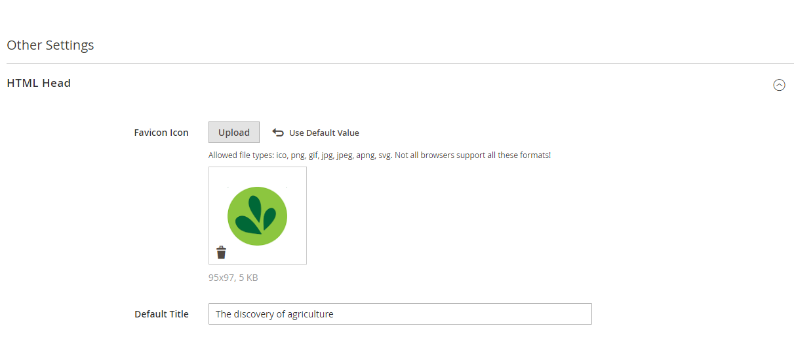

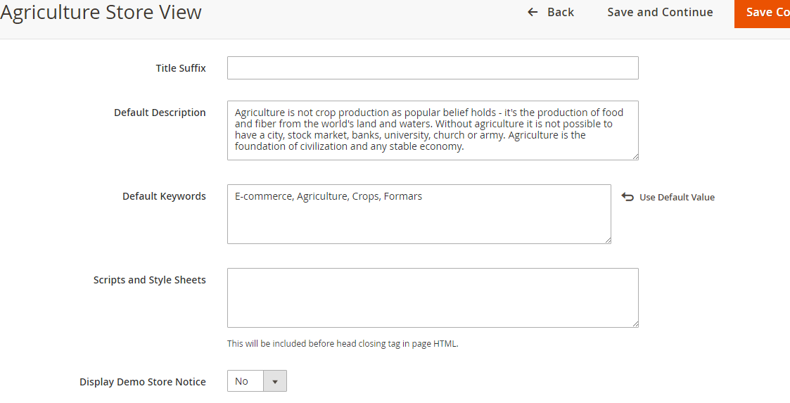

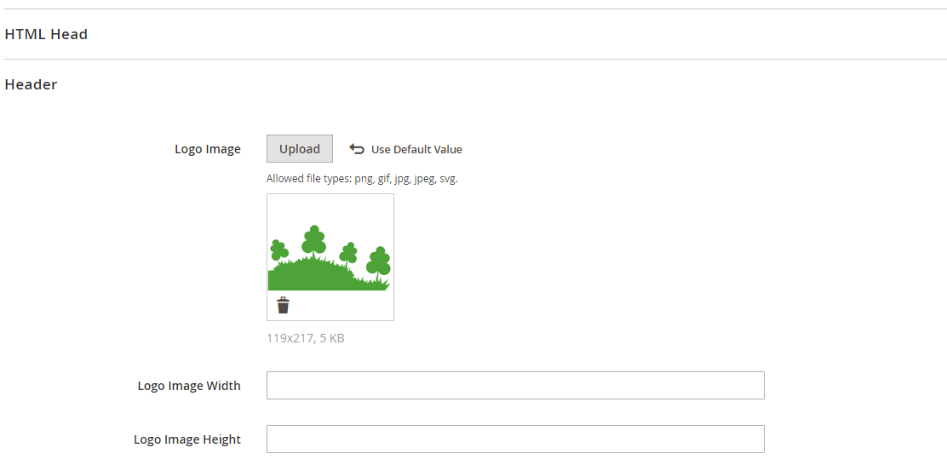

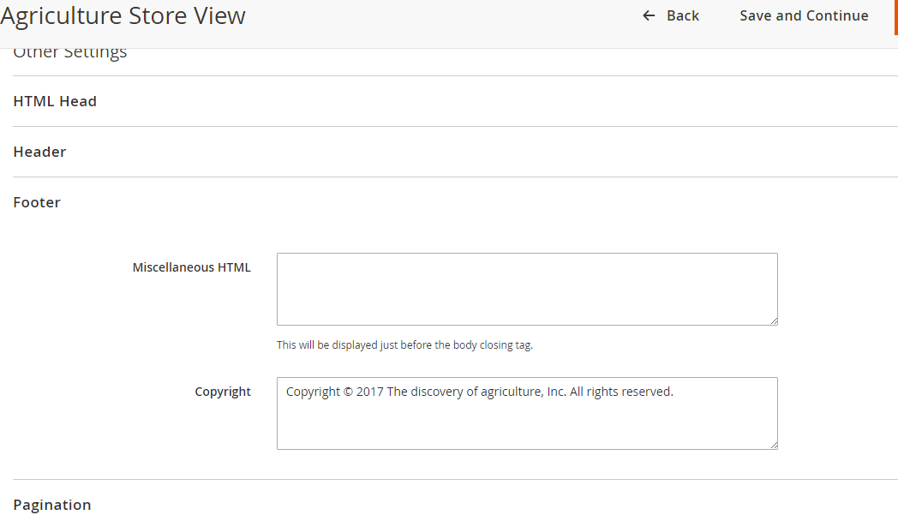

Finally Click on Save Configuration button to save the configurations.

That’s It Your done with the modifications you wanted.

**Step6:** Clear and Flush the cache and go to the website page then refresh. Your will reflect now.